Name: Munna Chauhan

Reg. No.: CH.EN.U4CSE22176

Lab Exp.: 05

-----------------------------------------------------------------------------------------------------------------------------------

Aim: To implement symbol table.

Code:

#include <stdio.h>

#include <stdlib.h>

#include <ctype.h>

int main() {

int x = 0, i = 0, j = 0;

void *T4Tutorials_address[50]; // Symbol addresses

char T4Tutorials_Array2[50]; // Input expression

char T4Tutorials_Array3[50]; // Symbols stored

char c;

printf("Input the expression ending with $ sign: ");

while ((c = getchar()) != '$') {

T4Tutorials_Array2[i++] = c;

}

int n = i - 1;

// Display the entered expression

printf("\nGiven Expression: ");

for (i = 0; i <= n; i++) {

printf("%c", T4Tutorials_Array2[i]);

}

// Display Symbol Table

printf("\n\nSymbol Table display\n");

printf("Symbol \t Address \t Type\n");

for (j = 0; j <= n; j++) {

c = T4Tutorials_Array2[j];

if (isalpha(c)) {

// Allocate memory for identifier (1 byte per char)

void *mypointer = malloc(sizeof(char));

T4Tutorials_address[x] = mypointer;

T4Tutorials_Array3[x] = c;

printf("%c \t %p \t identifier\n", c, mypointer);

x++;

} else if (c == '+' || c == '-' || c == '*' || c == '=') {

// Allocate memory for operator (1 byte)

void *mypointer = malloc(sizeof(char));

T4Tutorials_address[x] = mypointer;

T4Tutorials_Array3[x] = c;

printf("%c \t %p \t operator\n", c, mypointer);

x++;

}

}

// Free allocated memory

for (i = 0; i < x; i++) {

free(T4Tutorials_address[i]);

}

return 0;

}

Output:

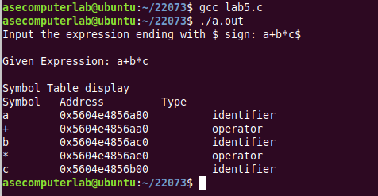

Result: Thus, the program to implement symbol table has been executed successfully.